Experiment 2

1. Create a collection by the name of Customer with the following attributes:

CustomerID

Balance

AccountType

1. Enter data into the collection

Commands:

1. db.createCollection(“Customer”)
2. db.Customer.insert({“custid”:1001,”accounttype”:”z”,”balance”:1500})

Output:

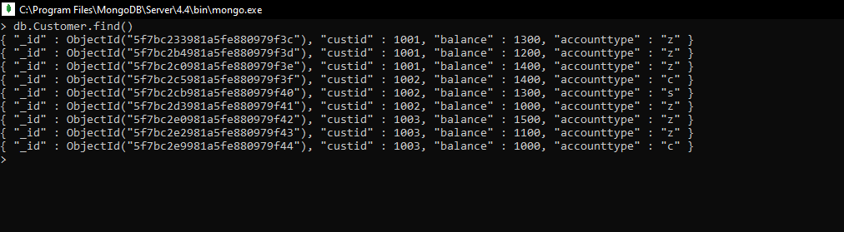

1. Write a query to display those records whose total account balance is greater than 1200 of account type “z” for each customer id

Command:

db.Customer.aggregate({$match:{"accounttype":"z"}},{$group:{_id:"$custid","totalbalance":{$sum:"$balance"}}},{$match:{"totalbalance":{$gt:1200}}})

Output:

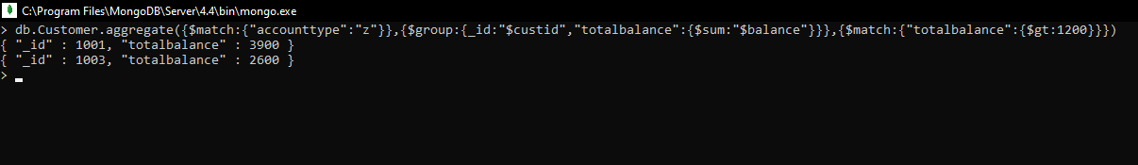

1. Determine minimum and maximum account balance for each customer

Command:

db.Customer.aggregate({$group:{_id:"$custid","totalbalance":{$min:"$balance"}}})

db.Customer.aggregate({$group:{_id:"$custid","totalbalance":{$max:"$balance"}}})

Output:

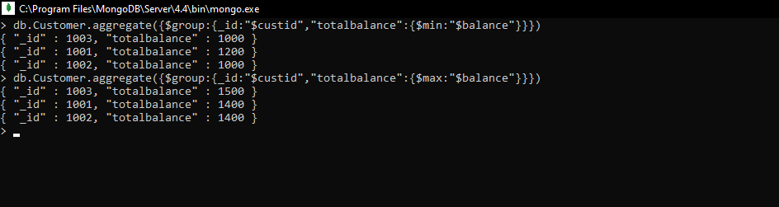

1. Drop the collection

Command:

Db.Customer.drop()

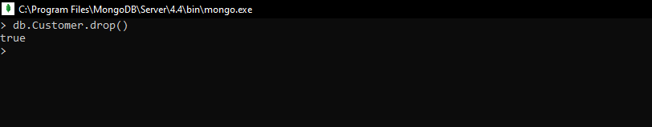Output:

1. Export the collection into the local system
   1. Command:

mongoexport --collection=customers --db=lab-03 --fields="cust_id,acc_bal,acc_type" --type=csv --out=customers.csv

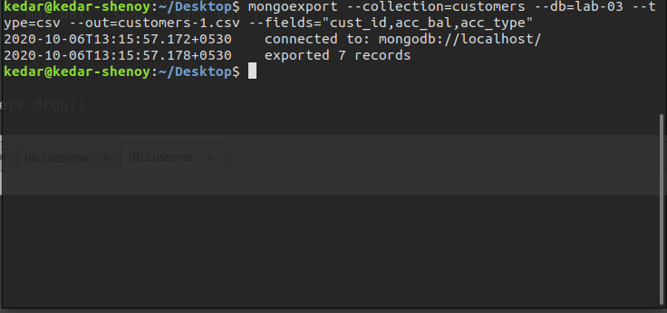

1. Import a dataset into the collection

Command:

mongoimport --collection=customers --db=lab-03 --type=csv --file=customers.csv --fields="cust_id,acc_bal,acc_type"

